To find the student’s English level scores go to **Test History**. Click on the arrow next to **AFE-Access for ELLs 2.0** for 15-16.

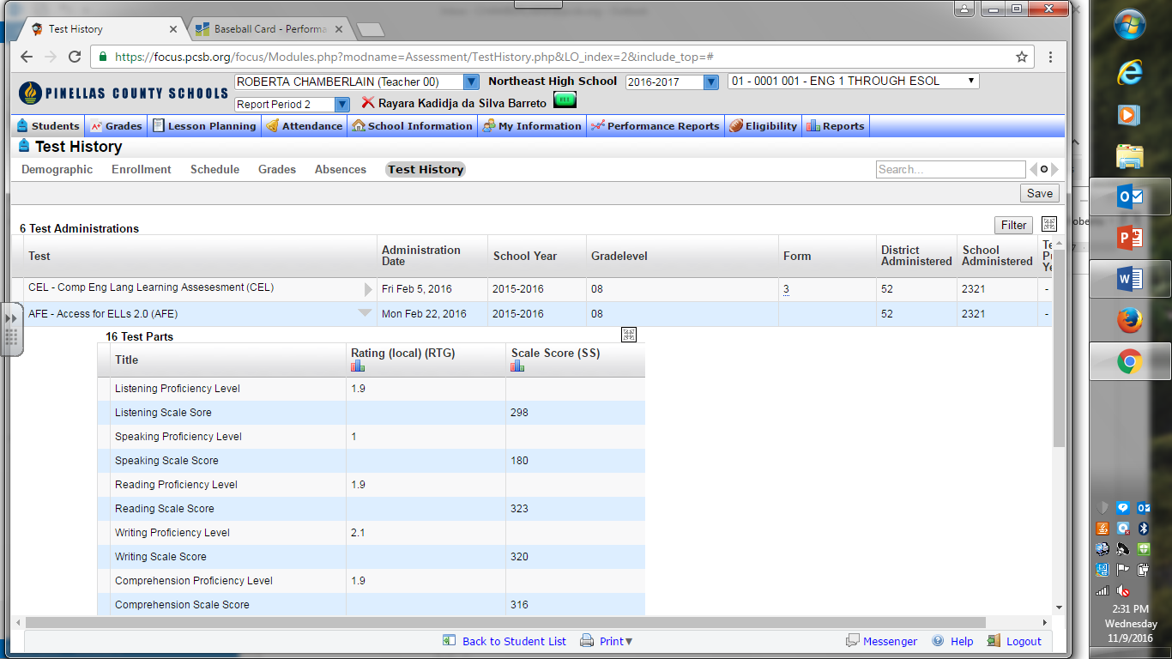

Look at the Rating (local) (RTG). You will see a number. That number matches the CAN DO descriptors 1-6. So if you are wondering what the ESOL student can do at that level, find the number in the CAN DO chart. Example: Reading level is 1.9 and Writing level is 2.1 the CAN DO level is Entering/Emerging.

Scroll down to the next page to see an example of the CAN DO pages.

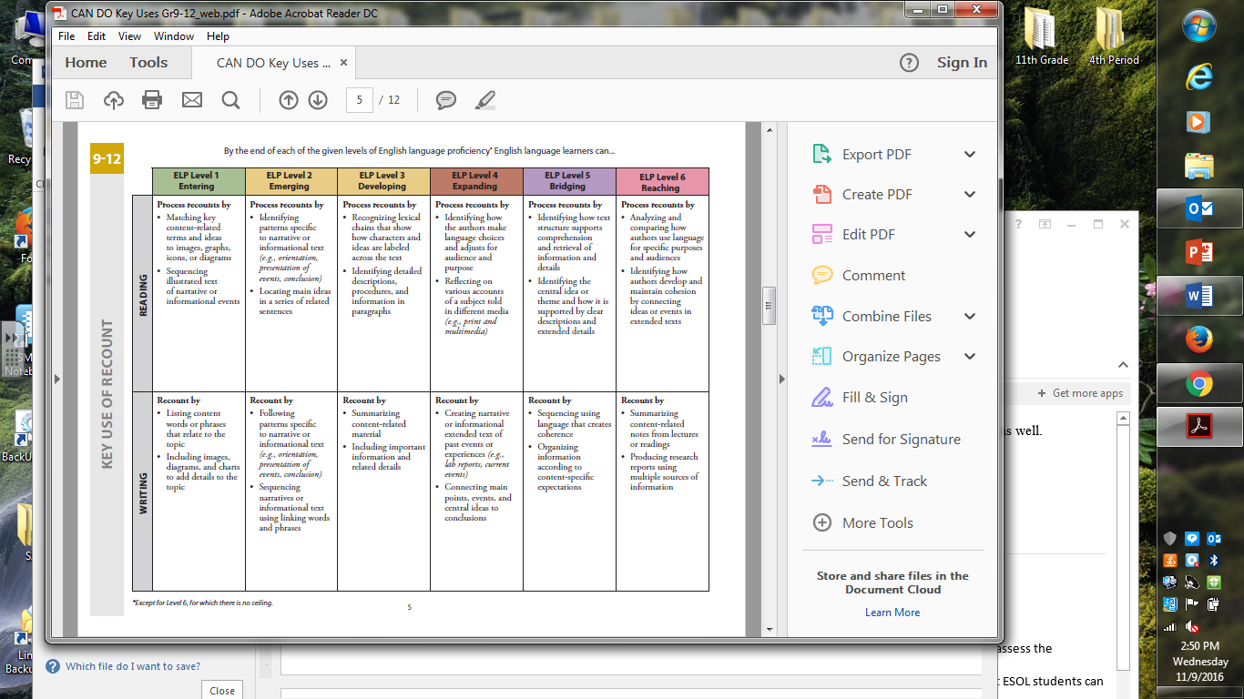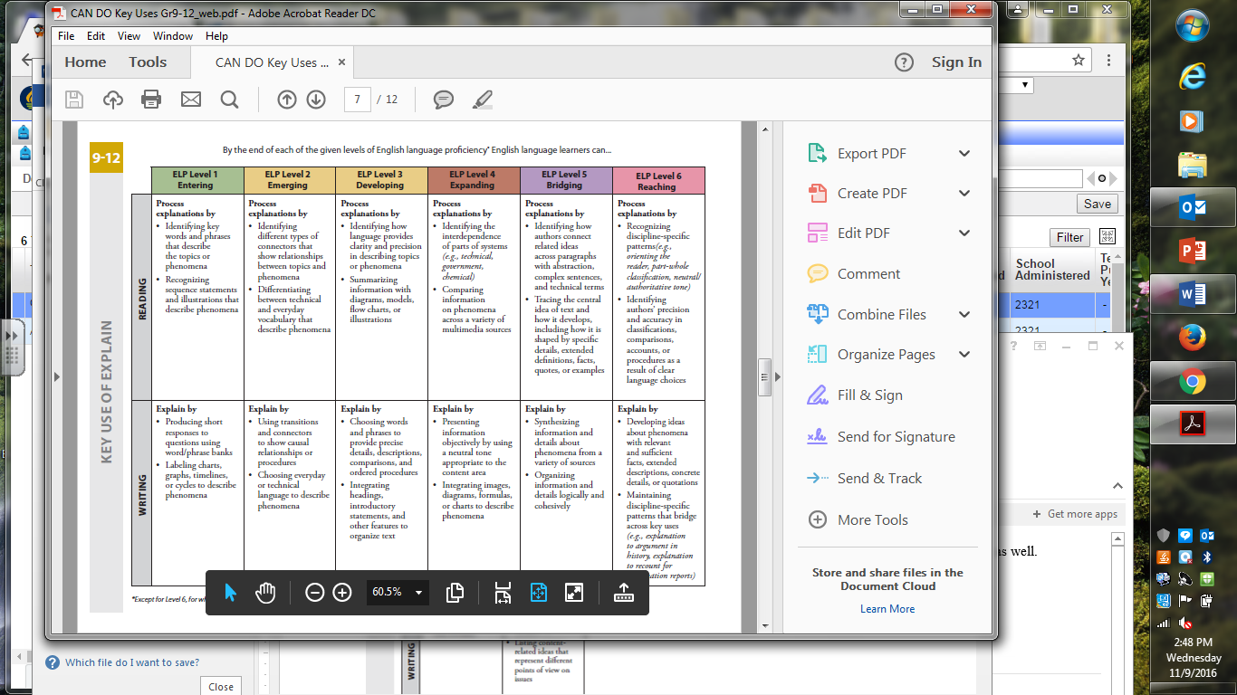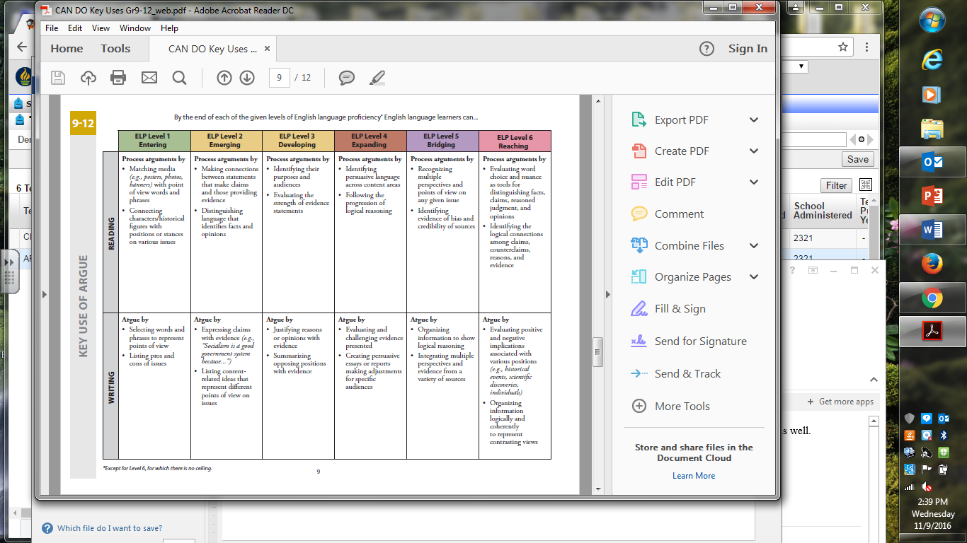 What the student is able to do with some success is:

What the student can do is match, identify, and select using key words and/or pictures. Level one is mostly copying work and translating vocabulary. At this level students are learning to read/ write English words. The student maybe able to read words (word calling) but does not understand what he/she is reading. The student at this level needs to be paired with a peer student for translations if speaking and listening are levels 1-2.

Level two is mostly using vocabulary words to create sentences and match terms used in academic courses. The student can read and comprehend lower Lexile level books and text with help. A peer student is still needed for translations if speaking and listening are levels 1-2.

Students at level one and two need extra time to complete assignments. They need to translate the assignment into their language, complete the task in their language, and then translate what they have done in to English to turn in for a grade. Do not expect them to compete the assignment in one class period. If you can give the ESOL student a translated or modified assignment that is the best way to provide accommodations.

What the student cannot do (in English) at level one or two: write summaries or essays, read /comprehend/ analyze / evaluate text, justify reasons, and identify bias.

Think of level one and two in this way… If you were given a text in Japanese (or a language you did not know) and you are told to read it and then answer the questions at the end during a 40 minute class, how accurate and fast could you complete the assignment?

Or

Read two articles and a prompt in Tagalog and write a five paragraph essay and cite the evidence. You cannot use the internet for translations. You only have a Tagalog/English dictionary. Could you do it? How long would it take you if Tagalog is not your native language?